Things that are above
Colossians 3:1-4
¹ If then you have been raised with Christ, seek the things that are above, where Christ is, seated at the right hand of God. ² Set your minds on things that are above, not on things that are on earth. ³ For you have died, and your life is hidden with Christ in God. ⁴ When Christ who is your life appears, then you also will appear with Him in glory.

- Christ is (vs 1)
… so seek after what is of Him (more than anything else)
One thing I do: forgetting what lies behind and straining forward to what lies ahead, I press on toward the goal for the prize of the upward call of God in Christ Jesus.
- Philippians 3:13-14
- Earthly thoughts are not (vs 2)
… so fully align yourself with God’s perspective
- Immerse yourself in God’s Word
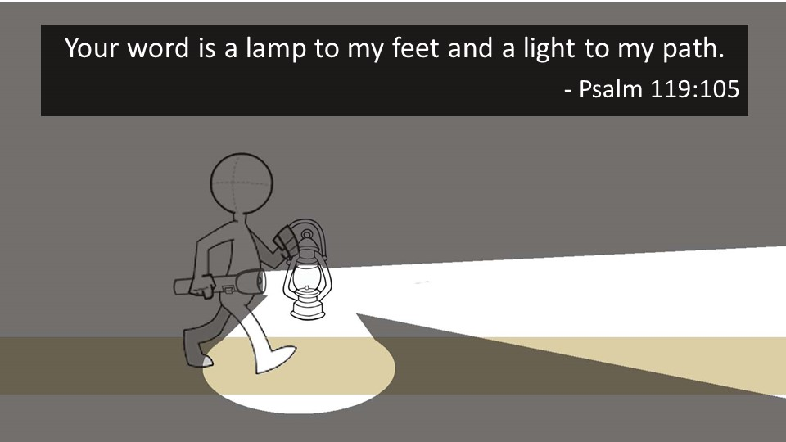
- Pray for God’s will to be fulfilled (and live accordingly)
- Surrender all other desires to His lordship
- Your spiritual identity is (vs 3-4)
… so base your motivations on that
Be motivated by:
- Your (past) separation from your dying sinful flesh
- Your (present) union with God
- Christ’s (future) return & the hope of your glorification

When Christ who is your life appears, then you also will appear with Him in glory.

Don’t look elsewhere for joy or satisfaction.
Apart from Him is death; so surrender to Him and live!

