“God’s Plan for Righteousness by Faith”

Discovering the Righteousness of God—A study in the book of Romans

Pastor Shaun McDonald

Romans 3:21-26 (ESV)

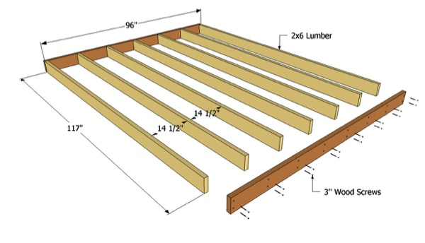
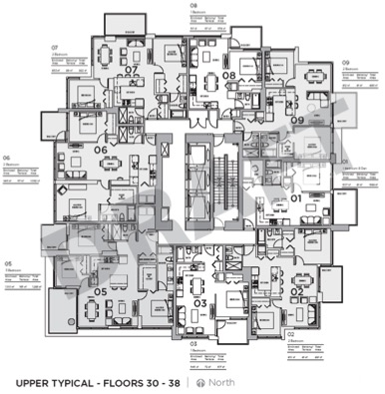

Romans 3:21-26
But now the righteousness of God has been manifested apart from the law, although the Law and the Prophets bear witness to it— 22 the righteousness of God through faith in Jesus Christ for all who believe. For there is no distinction: 23 for all have sinned and fall short of the glory of God, 24 and are justified by his grace as a gift, through the redemption that is in Christ Jesus, 25 whom God put forward as a propitiation by his blood, to be received by faith. This was to show God's righteousness, because in his divine forbearance he had passed over former sins. 26 It was to show his righteousness at the present time, so that he might be just and the justifier of the one who has faith in Jesus.

1) God’s plan for righteousness by faith was eternal

Ephesians 1:3-4
(3) Blessed be the God and Father of our Lord Jesus Christ, who has blessed us in Christ with every spiritual blessing in the heavenly places, (4) even as he chose us in him before the foundation of the world, that we should be holy and blameless before him.

2 Timothy 1:8-9
(8) Therefore do not be ashamed of the testimony about our Lord, nor of me his prisoner, but share in suffering for the gospel by the power of God, (9) who saved us and called us to a holy calling, not because of our works but because of his own purpose and grace, which he gave us in Christ Jesus before the ages began…

2) God’s plan for righteousness by faith was propitiation.

1 John 4:9-10
(9) In this the love of God was made manifest among us, that God sent his only Son into the world, so that we might live through him. (10) In this is love, not that we have loved God but that he loved us and sent his Son to be the propitiation for our sins.

Hebrews 12:1-2
(1) Therefore, since we are surrounded by so great a cloud of witnesses, let us also lay aside every weight, and sin which clings so closely, and let us run with endurance the race that is set before us, (2) looking to Jesus, the founder and perfecter of our faith, who for the joy that was set before him endured the cross, despising the shame, and is seated at the right hand of the throne of God.

3) God’s plan for righteousness by faith was just.

Isaiah 45:21
… And there is no other god besides me, a righteous God and a Savior; there is none besides me.

Zechariah 9:9
… Behold, your king is coming to you; righteous and having salvation is he, humble and mounted on a donkey, on a colt, the foal of a donkey.

